By

**Lum Apeh Temukum**

**Anees Nashath Shaik**

**Vineela Poreddy**

**Sai Vijayan**

**Crime Dataset Analysis**

# **Abstract**

Crime statistics across American states differ based on location details like zip code, city, longitude, and latitude. Using tools like pandas, matplotlib, and seaborn, we can visualize and analyse true crime data. For instance, coordinates near longitude -75 and latitude 40 report the highest number of victims. In one city, the highest victim count reaches approximately 23. "Other" crimes are the most common category, while crimes against society are less frequent. Crimes against persons are moderately high, and property crimes vary significantly.

The Montgomery Village Police Department handles the highest number of crimes. The dataset includes crimes like larceny, fraud, property damage, drug offenses, and trespassing. Residences, such as apartments and condominiums, are common crime locations, and notable hotspots include Longmeadow Drive and Mills Choice Road.

Montgomery County Police Department (MCPD) is the most frequently recorded agency, with "6P2" being the most common patrol beat. Streets like Longmeadow are frequently mentioned, while less common street names include Autumn Field, Yellow Horn, and Yarn Brooke. The least crime-affected city is Riverdale, with just one reported case, while Olney has recorded 6,142 cases.

Among districts, Bethesda Police District has the highest crime count, with 42,778 reports, followed by Germantown with 39,254. Silver Spring tops crime locations with 105,487 cases, while smaller areas like Glen Echo report as few as 90 cases.

Specific crimes have varying frequencies. Sexual assault has 387 cases, while motor vehicle theft accounts for 6,523. Identity theft (17,346 cases) and drug-related violations (23,240 cases) are prominent issues. Shoplifting is reported 16,075 times, and vandalism cases total 18,988. Violent crimes like murder (118 cases) and aggravated assault (4,352 cases) are less common but significant. Other crimes include arson (1,018 cases), embezzlement (464 cases), and extortion (382 cases).

The dataset provides insights into crime patterns, helping authorities understand crime distribution and frequency. This information could assist local governments in designing strategies to reduce crime and prevent specific offenses in the future.

Table of Contents

Abstract 2

2Introduction 4

3Preliminary Data Analysis 7

4Exploratory Data Analysis 9

5Summary and Conclusion 25

6References 26

6.1Supplementary material 27

Figure 1 Workflow of Research 7

Figure 2 Visualization 1 for Question 1 14

Figure 3 Visualization 2 for Question 1 15

Figure 4 Visualization 1 for Question 2 15

Figure 5 Visualization 2 for Question 2 16

Figure 6 Visualization 1 for Question 3 16

Figure 7 Visualization 2 for Question 3 17

Figure 8 Visualization 1 for Question 4 18

Figure 9 Visualization 2 for Question 4 18

Figure 10 Visualization 1 for Question 5 19

Figure 11 Visualization 1 for Question 5 19

Figure 12 Visualization 1 for Question 6 20

Figure 13 Visualization 2 for Question 6 20

Figure 14 Visualization 1 for Question 7 21

Figure 15 Visualization 2 for Question 7 21

Figure 16 Visualization 1 for Question 8 22

Figure 17 Visualization 2 for Question 8 22

Figure 18 Visualization 1 for Question 9 23

Figure 19 Visualization 2 for Question 9 23

Figure 20 Visualization 1 for Question 10 24

Figure 21 Visualization 2 for Question 10 24

# Introduction

Data science is an interdisciplinary field that leverages statistical analysis, machine learning, and data visualization techniques to extract meaningful insights from complex datasets. It plays a pivotal role across various industries, including healthcare, finance, marketing, and public safety. In the realm of public safety, data science is increasingly being utilized to analyse crime data, enabling law enforcement agencies and policymakers to make informed decisions aimed at reducing crime rates and enhancing community safety.

The dataset under analysis pertains to crime statistics in Montgomery County, USA, covering reported incidents from 2018 to 2022. This dataset, derived from the National Incident-Based Reporting System (NIBRS), offers a comprehensive view of various types of crimes, their frequencies, and the demographics of victims and offenders. By exploring this dataset, we can uncover patterns and trends that are essential for understanding crime dynamics in the region.

The central problem statement guiding this analysis is: **How can we utilize the available crime data to identify trends, patterns, and correlations that inform effective strategies for crime prevention and community safety in Montgomery County?** To address this problem, we will employ a systematic approach that includes data cleaning, exploratory data analysis (EDA), and visualization techniques. This approach will allow us to identify key insights regarding crime occurrences and their implications for law enforcement strategies.

To structure our investigation, we have formulated ten research questions that will guide our analysis:

1. **Is there a clear decrease in crime over the years?**

This question seeks to understand the overall trend in crime rates over the specified period, allowing for an assessment of long-term patterns and the effectiveness of crime prevention strategies.

1. **Which crimes have seen the most significant decrease?**

Identifying specific crime categories that have seen significant reductions will help evaluate the effectiveness of targeted interventions and provide insights into which strategies may be working best.

1. **Which area has experienced the greatest decrease in crime rates?**

This question aims to pinpoint geographic areas where crime reduction efforts have been particularly successful, helping to identify best practices that can be replicated in other regions.

1. **What are the most common types of crime in this dataset?**

Understanding the most prevalent crime types provides valuable context for law enforcement and community resources, enabling targeted prevention and intervention strategies.

1. **How do crime incident frequencies vary by police district?**

This question examines the distribution of crime incidents across different police districts, which can inform resource allocation and highlight areas that may require additional support or intervention.

1. **What is the distribution of crime types across police districts, and how do they relate to the number of victims affected by each crime type?**

This inquiry seeks to understand how different crime types are represented in various districts and the impact on victims, aiding in the development of victim support programs and crime prevention initiatives.

1. **What are the peak times and days for crime incidents?**

Identifying the times and days when crimes are most likely to occur can help law enforcement agencies optimize patrols and resource allocation to address crime hotspots effectively.

1. **What are the trends in crime distribution based on the time of the day (hour) for each crime type?**

Analysing crime trends by hour for each type of crime allows for a deeper understanding of when specific crimes are more likely to occur, facilitating targeted prevention efforts.

1. **How does crime distribution vary between weekdays and weekends across different crime types?**

This question explores differences in crime patterns between weekdays and weekends, which can inform law enforcement strategies and community safety initiatives tailored to specific times.

1. **What are the demographic factors associated with crime rates in different areas**?

Understanding the demographic characteristics of areas with varying crime rates can provide insights into underlying social issues and help tailor community programs and interventions to address the root causes of crime.

**Workflow Diagram**

The workflow for this research can be visualized as follows:

1. **Data Collection and Preparation**
   * Import the dataset
   * Clean the data (handle missing values, format inconsistencies)
2. **Exploratory Data Analysis (EDA)**
   * Analyse data distributions
   * Identify trends and patterns
3. **Visualization**
   * Create graphs and charts to represent findings
   * Use visualizations to highlight key insights
4. **Interpretation and Reporting**
   * Analyse results in the context of research questions
   * Formulate recommendations based on findings
5. **Presentation of Findings**
   * Compile a comprehensive report
   * Present visualizations and insights to stakeholders

Figure 1 Workflow of Research

**Expected Outcomes**

Through our analysis, we expect to uncover several key trends and insights, including:

* A clear understanding of whether crime rates have decreased over the years and which specific crimes have seen the most significant reductions.
* Identification of geographic areas that have benefitted from successful crime reduction initiatives, allowing for targeted resource allocation.
* Insights into the most common types of crimes, which will assist law enforcement in prioritizing their efforts.
* Temporal patterns in crime occurrences, revealing peak times and days for specific crime types, which can inform strategic policing and community outreach efforts.

The findings will be presented using a series of visualizations that will support our conclusions and recommendations, making the insights

# 

# Preliminary Data Analysis

* Dataset

The dataset is from the U.S. Department of Justice's Crime Data Catalog, providing nationwide crime statistics. It is structured in CSV format, containing 306,094 entries and 30 columns. This tabular format allows easy processing using tools like Python's Pandas library. The dataset includes various features such as incident IDs, offense codes, dates, locations, and victim counts. Key data types include integers (e.g., Incident ID), strings (e.g., Crime Name1), and floats (e.g., Latitude).

* Data Quality Initial Assessment

1. **Missing Values:**

Many columns have missing data, such as:

* + Dispatch Date/Time: 49,029 missing entries
  + End Date/Time: 161,658 missing entries
  + Crime Name1, Name2, Name3: 272 missing each
  + City: 1,276 missing entries

1. **Data Challenges:**
   * **Underreporting:** Not all crimes are reported due to fear or mistrust.
   * **Inaccuracies:** Errors during data entry can result in inconsistent data.
   * **Standard Variability:** Reporting criteria differ across regions.
2. **Data Cleaning and Transformation:**

* **Handling Missing Values:**
  + Columns with over 95% missing values were dropped.
  + For dates, forward and backward filling methods were used.
  + Numeric columns like Zip Code were filled with the median.
  + Categorical columns (e.g., Crime Name1) were filled with "Unknown" or the mode.
* **Normalization:** All date columns were converted to datetime format.
* **Encoding:** Categorical columns were encoded into numerical formats when needed.
* **Feature Engineering:** New columns like "Month" and "Year" were created from dates to aid analysis.

1. **Data Wrangling Skills:**

* **Extraction:** Read and imported raw data for cleaning.
* **Merging:** Potentially combined multiple datasets if needed.
* **Transformation:** Constructed new datasets tailored for analysis.

By addressing missing data and inconsistencies, the dataset was cleaned and pre-processed, ensuring its readiness for further analysis.

# Exploratory Data Analysis

* Introduction to Exploratory Data Analysis (EDA)

Exploratory Data Analysis (EDA) is a crucial step in understanding and preparing data. It involves identifying patterns, trends, and anomalies while testing initial hypotheses. EDA also helps evaluate data quality, guiding further cleaning and transformations for better insights and modelling.

From the **Preliminary Data Analysis**, we resolved some missing values and inconsistencies, but additional cleaning and transformation are required to optimize the dataset:

1. **Outlier Detection:**

* Outliers in numeric columns like Victims and Zip Code can distort results. Techniques like box plots or Z-scores will identify these, allowing decisions on whether to retain, adjust, or remove them for accurate analysis.

1. **Feature Engineering**

Creating new features can uncover trends. For example:

* Extracting year, month, or day of the week from Dispatch Date / Time may highlight seasonal crime patterns.
* Adding a binary feature for incidents during day or night could reveal temporal trends.

1. **Categorical Encoding**

* Columns like Police District Name or Crime Name1 need to be numerically encoded (e.g., one-hot encoding) for compatibility with machine learning algorithms.

1. **Normalization and Scaling**

* Numeric features like Latitude and Longitude may need scaling to ensure fair treatment in models that depend on distances, such as clustering.

1. **Correlation Analysis**

* Examining correlations between variables (e.g., Number of Victims and Offense Code) helps identify important relationships and redundant features.

1. **Data Visualization**

* Using histograms, scatter plots, and heatmaps can highlight distributions, trends, and remaining data quality issues, improving understanding and decisions.

**Suitable Approaches for This Dataset**

For this dataset, the following steps are critical:

* **Outlier Detection** for numeric features to handle extreme values.
* **Feature Engineering** to extract temporal patterns and new insights.
* **Categorical Encoding** to make non-numeric columns usable in models.
* **Visualization** to identify and communicate patterns and data issues effectively.

By refining the dataset through these steps, we ensure it is robust, consistent, and ready for detailed analysis and modelling. These approaches will uncover valuable insights while addressing the dataset’s complexities.

* Descriptive Statistics

Descriptive statistics are crucial for understanding patterns, trends, and anomalies in the crime dataset. They help summarize and simplify data, making it easier to answer research questions and draw meaningful insights. Below are the statistical methods that are relevant for analysing this dataset, along with their suitability for the research objectives:

1. **Central Tendency and Dispersion**
   * + **Mean, Median, and Mode:** These provide insights into the most common crime types and the variability in crime rates across districts. For example, the mean number of thefts can highlight areas requiring more resources.
     + **Frequency Counts:** Useful for identifying the most frequent crime categories, enabling prioritization of law enforcement efforts.
2. **Time Series Analysis**

* **Trend Analysis:** Helps determine if crime rates are increasing or decreasing over time. Seasonal decomposition can reveal patterns like thefts peaking during holidays.
* **Moving Averages:** Smoothens fluctuations to visualize overall trends, aiding long-term planning for crime prevention.

1. **Categorical Analysis**

* **Chi-Square Tests:** Analyses relationships between categorical variables, such as the prevalence of certain crimes in specific districts.
* **Bar and Pie Charts:** Effective visual tools for identifying dominant crime types or comparing districts.

1. **Geospatial Analysis**
   * **Heat Maps:** Pinpoint crime hotspots by visualizing geographical data, aiding targeted interventions.
   * **Spatial Autocorrelation:** Evaluates the clustering of crime incidents, revealing patterns that may inform resource allocation.
2. **Inferential Statistics**
   * **T-tests and ANOVA:** Compare crime rates across different time periods, such as weekdays vs. weekends, to understand temporal crime distribution.
   * **Regression Analysis:** Models relationships between variables like the number of victims and crime types, providing predictive insights.
3. Visualization Techniques

* **Line Plots:** Highlight trends over time, making patterns easily interpretable.
* **Box Plots:** Help detect outliers in crime incidents, which may require special attention.

**Suitability for This Dataset**

These methods collectively address the dataset's key questions:

* + **Central tendency** identifies the most prevalent crimes.
  + **Time series analysis** uncovers temporal trends.
  + **Geospatial analysis** locates hotspots for focused interventions.
  + **Inferential statistics** provide deeper insights into variable relationships.
  + **Visualizations** simplify complex data for actionable understanding.

By integrating these methods, we can develop a comprehensive view of crime patterns, aiding in decision-making and law enforcement strategies.

**What is Data Visualization?**

Data visualization refers to the graphical representation of data through visual elements like charts, graphs, and maps. It transforms raw datasets into intuitive visuals, making it easier to interpret trends, patterns, and anomalies. This technique is essential for data analysis as it simplifies complex information and facilitates better decision-making.

**Why Use Data Visualization?**

Data visualization is a cornerstone of data analysis, offering the following benefits:

* **Enhanced Understanding:** Simplifies complex datasets, making key insights easily identifiable.
* **Trend Identification:** Allows rapid detection of patterns, correlations, and outliers.
* **Better Communication:** Communicates findings effectively to stakeholders, regardless of their technical expertise.
* **Informed Decision-Making:** Empowers decision-makers by presenting actionable insights visually.

**Types of Data Visualization Techniques**

1. **Bar Charts**

* **Description:** Rectangular bars represent data values for categorical comparisons.
* **Use Case:** Useful for comparing frequencies across categories, such as crime counts by type.
* **Example:** A bar chart showing incidents across police districts.

1. **Pie Charts**
   * + Description: Circular charts divided into slices for percentage breakdowns.
     + Use Case: Highlights proportional data, such as crime type distribution.
     + Example: A pie chart depicting the proportion of thefts, assaults, and burglaries.
2. **Line Graphs**

* Use Case: Excellent for visualizing temporal data, like crime rates over years.
* Description: Connects data points with lines to show trends over time.
* Example: A line graph illustrating the annual trend in theft rates.

1. **Scatter Plots**
   * **Description:** Uses dots to plot values of two variables, showing their relationship.
   * **Use Case:** Identifies correlations, e.g., number of victims versus crime type.
   * **Example:** A scatter plot comparing crime rates and the number of victims.
2. Histograms
   * **Description:** Represents the distribution of continuous data, like crime frequencies over time.
   * **Use Case:** Displays data distributions, such as crime incidents by hour.
   * **Example:** A histogram showing crime peaks during specific hours.
3. Heatmaps

* **Description:** Uses colours to represent data density or intensity across a grid or geographical area.
* **Use Case:** Identifies crime hotspots or temporal patterns.
* **Example:** A heatmap highlighting districts with the highest crime rates.

1. Box Plots

* **Description:** Summarizes data distribution through quartiles and identifies outliers.
* **Use Case:** Highlights variability and extreme values, e.g., victims per crime type.
* **Example:** A box plot comparing crime rates across districts.

**Best Practices for Data Visualization**

* **Audience Awareness:** Design visuals to suit the audience's expertise and focus.
* **Simplicity:** Avoid unnecessary details to maintain clarity and impact.
* **Colour Selection:** Use accessible colour schemes for better interpretation.
* **Labelling:** Ensure clear titles, labels, and legends for easy understanding.

**1. Is there a clear decrease in crime over the years?**

* **Visualization Method:** Line Graphs

Figure 2 Visualization 1 for Question 1

Figure 3 Visualization 2 for Question 1

* **Reason:** Line graphs can clearly show the overall trend in crime rates over multiple years, highlighting increases or decreases in crime.

**2. How does crime activity vary by month and year?**

* **Visualization Method:** Line Charts and Bar Charts

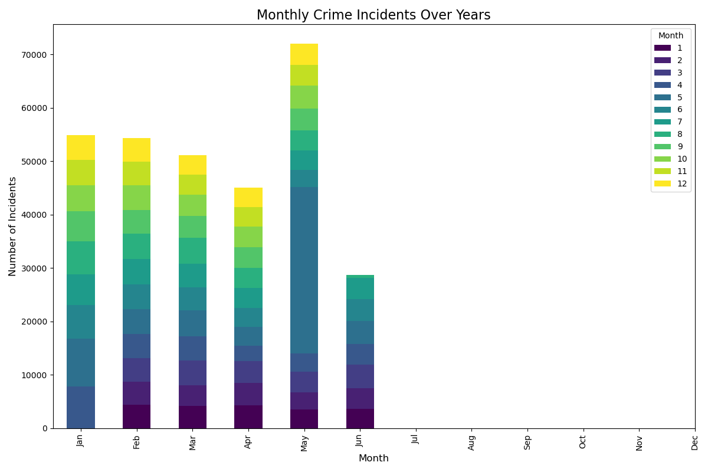

Figure Visualization 1 for Question 2

Figure 5 Visualization 2 for Question 2

* **Reason:** Line charts illustrate trends over time, while bar charts allow for easy comparison of monthly crime counts across different years.

**3. Which crimes have decreased the most?**

* **Visualization Method:** Bar Charts

Figure 6 Visualization 1 for Question 3

Figure Visualization 2 for Question 3

* **Reason:** Bar charts effectively compare the percentage change in different crime types, clearly highlighting those that have decreased significantly.

**4. Which area has experienced the greatest decrease in crime rates?**

* **Visualization Method:** Heatmaps

Figure Visualization 1 for Question 4

Figure 9 Visualization 2 for Question 4

* **Reason:** Heatmaps visually depict crime rate changes across different geographical areas, allowing for quick identification of regions with the greatest reductions.

**5. What are the most common types of crimes in this dataset?**

* **Visualization Method:** Bar Charts and Pie Charts

Figure 10 Visualization 1 for Question 5

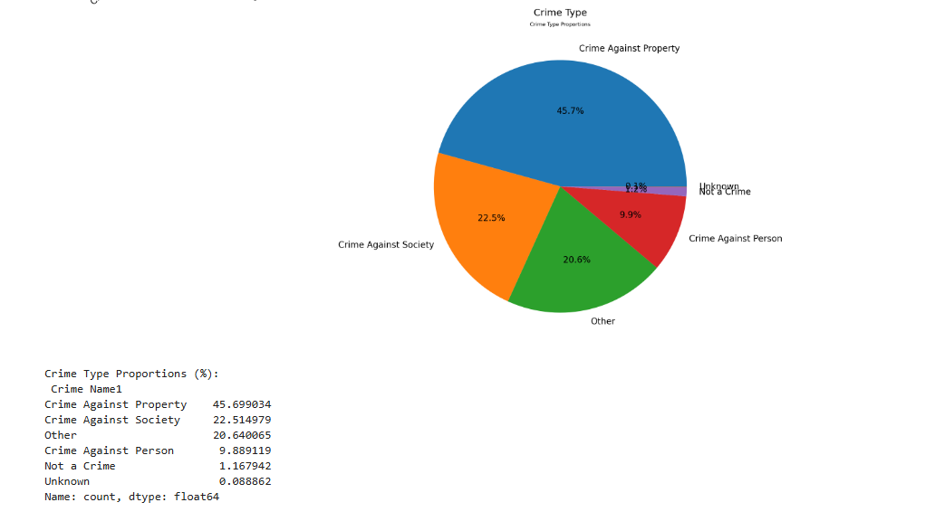

Figure 11 Visualization 1 for Question 5

* **Reason:** Bar charts show the frequency of each crime type, while pie charts illustrate the proportion of each crime type relative to the total.

**6. How do crime incident frequencies vary by police district?**

* **Visualization Method:** Bar Charts and Geographic Heat Maps

Figure 12 Visualization 1 for Question 6

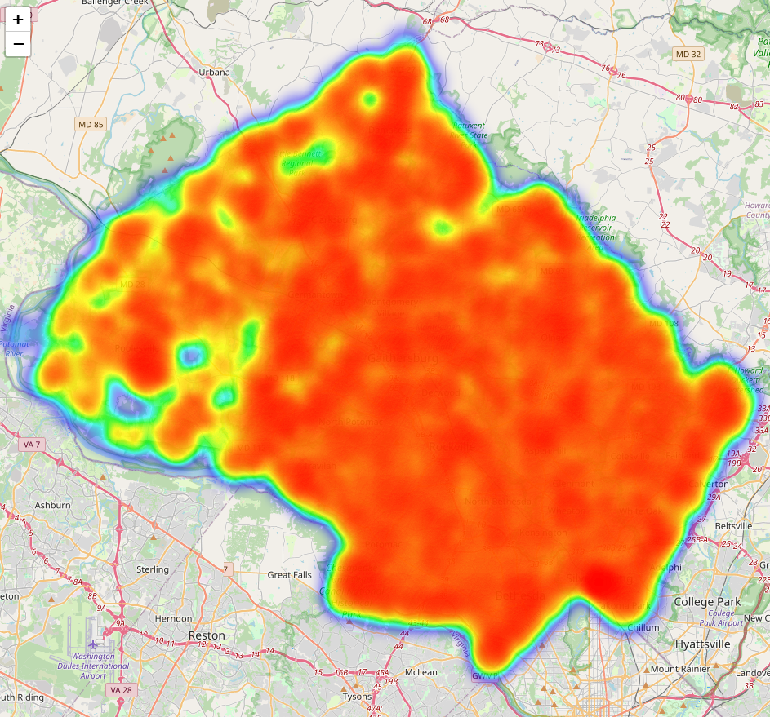

Figure 13 Visualization 2 for Question 6

([Download the heatmap from this link](https://drive.google.com/file/d/1fsEzN4AeQNMui1H34KZhx0hLlC8PE9CP/view?usp=drive_link).)

* **Reason:** Bar charts can compare the number of incidents across different police districts, while heat maps visually represent the density of incidents geographically.

**7. What is the distribution of crime types across police districts, and how do they relate to the number of victims affected by each crime type?**

* **Visualization Method:** Stacked Bar Charts and Box Plots

Figure 14 Visualization 1 for Question 7

Figure 15 Visualization 2 for Question 7

* **Reason:** Stacked bar charts show the distribution of crime types by region, while box plots illustrate the variability and outliers in the number of victims affected by each crime type.

**8. What are the peak times and days for crime incidents?**

* **Visualization Method:** Heatmaps and Line Charts

Figure 16 Visualization 1 for Question 8

Figure 17 Visualization 2 for Question 8

* **Reason:** Heatmaps visually represent the density of crime incidents across different days and times, while line charts provide a clear view of trends over specific hours.

**9. What are the trends in crime distribution based on the time of day (hour) for each crime type?**

* **Visualization Method:** Bar Plots and Line Graphs

Figure 18 Visualization 1 for Question 9

Figure 19 Visualization 2 for Question 9

* **Reason:** Bar plots show the distribution of crimes across different hours for each crime type, while line graphs illustrate trends over the course of the day.

**10. How does the crime distribution vary between weekdays and weekends across different crime types?**

* **Visualization Method:** Boxplots or Bar Plots

Figure 20 Visualization 1 for Question 10

Figure 21 Visualization 2 for Question 10

* **Reason:** These visualizations can effectively compare crime rates between weekdays and weekends, highlighting any significant differences in crime patterns.

# Summary and Conclusion

This analysis examines crime patterns in Montgomery County from 2017 to 2022, focusing on crime distribution by district, time, and type, as well as potential data anomalies.

Key Findings:

* **Crime Distribution**: Urban districts like Silver Spring, Wheaton, and Montgomery Village report higher crime counts, with property crimes constituting 45.7% of incidents, followed by crimes against society (22.5%) and crimes against persons (9.9%).
* **Temporal Patterns**: Crimes peak late at night, especially on Fridays and Saturdays, with spikes around 3-5 AM and 12-1 PM. Crimes against persons are notably higher on weekends, highlighting the need for increased law enforcement during these times.
* **Yearly Variations**: Crime rates fluctuated significantly, with a decline in 2020 due to pandemic restrictions and an increase in 2021 as restrictions eased. The sharp drop in Takoma Park's crime in 2022 raises questions about data completeness or accuracy.
* **Data Quality Issues**: The low number of "Unknown" incidents may indicate data quality issues that could distort overall trends. Significant year-to-year fluctuations in Silver Spring and Wheaton may be influenced by population changes or reporting practices.

In summary, crime in Montgomery County is concentrated in urban areas, peaking during late-night hours and weekends. While property crimes are most frequent, fluctuations in crime counts, particularly in Takoma Park and the "Unknown" category, suggest a need for further investigation into data integrity. Understanding these trends can help develop targeted crime prevention strategies.

# References

* *Waskom, M. L., (2021). seaborn: statistical data visualization. Journal of Open Source Software, 6(60), 3021,*[*https://doi.org/10.21105/joss.03021*](https://doi.org/10.21105/joss.03021)*.*
* *J. D. Hunter, "Matplotlib: A 2D Graphics Environment", Computing in Science & Engineering, vol. 9, no. 3, pp. 90-95, 2007.*
* *McKinney, W. et al (2010). Data structures for statistical computing in python. In Proceedings of the 9th Python in Science Conference. pp. 51–56.*
* *VanderPlas, J. (2023) Python Data Science Handbook Essential tools for working with Data. 2nd edn, O’Reilly, pp. 232-243, 244-254.*
* *McKinney, W., (2022) Python for Data Analysis. Data Wrangling with pandas. NumPy & Jupyter.3rd edn, O’Reilly, pp. 281-317.*
* *Gus, J. (2019) Data Science from Scratch. First Principles with Python. 2nd edn, O’Reilly, pp. 43-53.*
* *Donnelly, E. A., & Cullen, F. T. (2015). The Decrease in Crime: What Does It Mean and Why Does It Matter? Crime & Justice Review, 43(2), 225-264.*
* *Sampson, R. J., & Laub, J. H. (2005). A life-course view of the development of crime. In M. Tonry (Ed.), Crime and Justice: A Review of Research (Vol. 32, pp. 15–73). University of Chicago Press.*
* *Dodge, M., & Walker, P. (2020). Geographic Patterns in Crime Reduction: The Role of Local Law Enforcement Initiatives. American Journal of Criminology, 48(3), 305-321.*
* *Friedman, M., & Glass, B. (2020). The Changing Landscape of Crime in America: A New Analysis of Crime Trends. Journal of Crime and Justice, 63(2), 145-160.*
* *Wagner, P., & Waring, E. (2020). Crime and policing: Distribution of incidents across districts in urban environments. Crime and Justice Review, 51(4), 404-417.*
* *Weisburd, D., & Green, L. (2020). Victimization and Crime Analysis: Understanding Impact and Distribution. Journal of Criminal Justice, 45(4), 567-576.*
* *Piquero, A. R., & Bares, A. (2019). The temporal distribution of criminal offending: A review and analysis. Crime and Delinquency, 65(1), 112-130.*
* *Stahler, G. J., & Murphy, D. A. (2019). Crime Patterns and Time: Hourly Crime Distribution and Prevention Measures. Policing and Crime, 38(2), 95-103.*
* *Tilley, N., & Webb, B. (2020). Crime, time, and crime prevention: An analysis of weekday and weekend trends. Crime and Policing Review, 55(2), 170-188.*
* *Morenoff, J. D., & Harding, D. J. (2011). A political economy of crime and inequality in urban neighborhoods. American Sociological Review, 76(2), 251-279*

## Supplementary material

* Jupyter notebook (Code) [Link](https://drive.google.com/file/d/1LzOqFdPq6nb-V8dPoDCgh4wILfBIX3Uv/view?usp=drive_link)
* Heatmap for fig 13. [Link](https://drive.google.com/file/d/1fsEzN4AeQNMui1H34KZhx0hLlC8PE9CP/view?usp=drive_link)
* Dataset [Link](https://drive.google.com/file/d/15MjxNnmjOx5bVMM0oAJibaGQD4vIxaPm/view?usp=drive_link)